Least Squares and Normal Equations

Geometrical interpretation of the least square method

The idea of the least square method is to solve a set of linear equations which has no exact solution in such a way to minimize the error. To precise this idea let us consider an example.

Consider following set of linear equations:

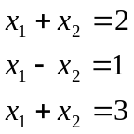

You can easily convince yourself that this set of equations has no solution. We say that the set of equation is inconsistent.

Let us no assume that we would like to solve this inconsistent set of equation in such a way to get a solution that satisfies all equations as good as possible. We have to define what we mean by “as good as possible”.

Remember what we have seen about the least square method. We did define the least square solution of a system 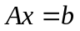 by saying that is the least square solution of if the root-mean-square error 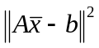 is minimized.

Formulated in such a way, the least square method has a very intuitive geometrical interpretation. It says in fact that the vector has to be chosen in such a way that the vector 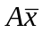 is as close as possible to the vector , where “as close as possible” means that we minimize the Euclidian distance between the tow vectors and .

Let us apply this finding to our example. First we rewrite the problem in matrix form:

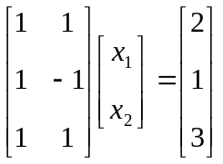

We want now to find the vector in such a way that the distance between and is as small as possible. Let us solve this geometrically. First not that the vector is in a certain well defined plane. In which plane? In the plane defined by the two vectors

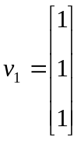 and 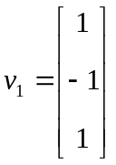

Indeed, this fact becomes evident by considering following relation:

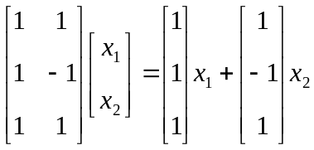

That means that any vector we may consider to be solution of our problem is such that is necessarily in the plane defined by the two vectors 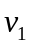 and 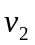. Now the solution of our problem becomes clear. Which vector is now as close as possible to ? It is the orthogonal projection of on the plane defined by the two vectors and (see figure below).

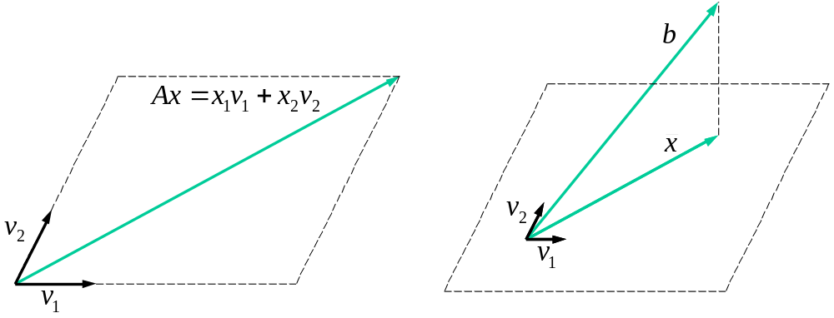
Figure 1: Left: an example of a vector 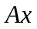. Right: The vector minimising the distance between and is the orthogonal projection of on the plane defined by the two vectors and .

From this geometrical interpretation we can as well give a intuitive view of the sum of the squares of the residuals 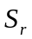 (equation 17.3 from your textbook). Comparing equation (17.3) from your textbook and you will see that:

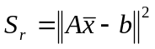

In other words, the sum of the squares of the residuals is nothing else as the Euclidian distance between and the “as good as possible” solution .

Normal equations

The geometrical interpretation of the least-square method described above, can now be used to develop a general method to compute the least square solution of a system .

We have established above that the least square solution of the system , where 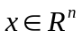, is the vector which is the orthogonal projection on the sub-space defined by all vectors of the form . Or in other words:

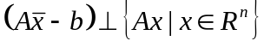

This can be expressed by following equation:

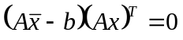 for all

Using known algebraic manipulations on transposes we get:

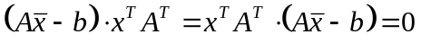 for all

What does this equation mean? It says that the n-dimensional vector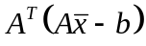 is perpendicular to every vector , including itself. There is only one possibility to satisfy this condition:

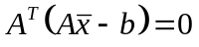

Or equivalently:

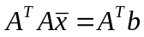

This system of n equations in n unknowns, is known as the normal equations of the lest square method.

The problem of finding the least square solution of a set of linear equations can therefore be formulated as follows:

Last square solution using the normal equations

Given the inconsistent system

solve
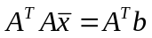

to find the last square solution .

Note: The matrix 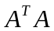 is symmetric as 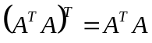. This means that you have to compute only either the upper or lower part of the matrix.

Example

Find the last square solution of the system:

First we write this system in matrix form:

Therefore we have:

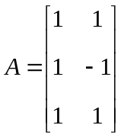 and 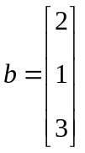

Let us now write the normal equations. We first compute:

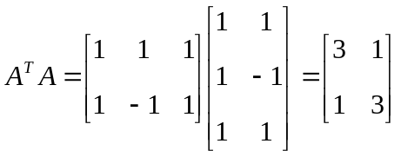
and
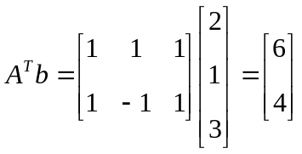

The normal equations are:

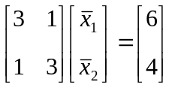

The solution is:

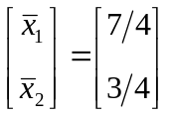

To evaluate our success of fitting the data, we calculate the sum of the squares of the residuals 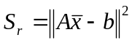. We first compute:

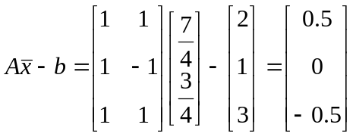

and therefore:

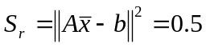

General linear least squares

As discussed in section 17.4 of your textbook, the technique of the normal equations can be applied to a very general case of linear regression. The most general case where the normal equations can be applied is when you try to fit your data to following model:

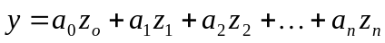

where 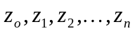 are any kind of basis functions. The parameters 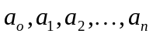 have to adjusted in such a way that the model minimises the least square error of the data.

Let us consider an example to show how it works.

Example

Consider following data.

 | 0 | 1 | 2 | 3 | 4 | 5
 | 2.1 | 7.7 | 13.6 | 27.2 | 40.9 | 61.1

We want to fit following model to the data:

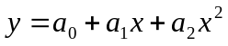

To apply the normal equation technique, we first formulate the problem as a set of inconsistent linear equations. Fitting the data means to satisfy in the best way possible following set of linear equations:

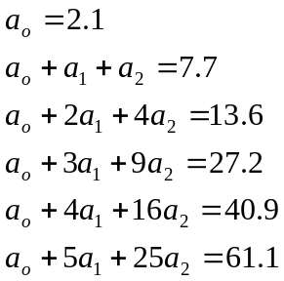

or written in matrix form:

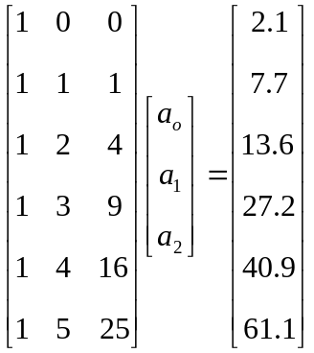

Therefore we have:

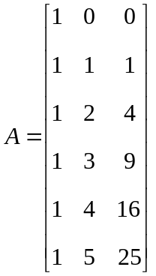 and 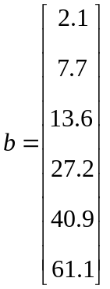

Let us now write the normal equations. We first compute:

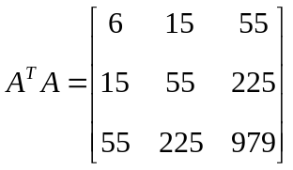

which is symmetric as expected, and

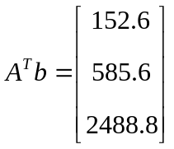

The normal equations are:

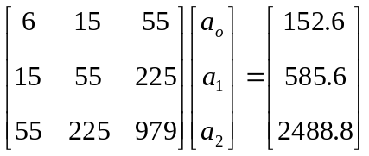

The solution is (using for example MatLab):

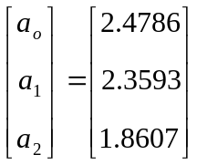

It is instructive to compare this example with the one from your text-book. You will see that you have to solve exactly the same set of linear equations.

We can as well check the sensitivity of our method to numerical errors. Therefore we have to consider the conditioning number of the matrix . In our previous example we get:

>> A=[1 0 0
1 1 1
1 2 4
1 3 9
1 4 16
1 5 25];
>> cond(A’*A,inf)
ans =
1.8885e+003

Therefore we can expect, using double precision numbers, 16-3=13 significant digits in this case.

As with any numerical method, you should be careful when using it. As shows following example, the least square regression with polynomials of high order can rapidly become an ill conditioned problem.

Example

Let us consider following set of data:

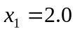, 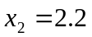, 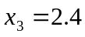, …, 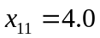
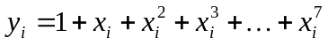

Let us now fit this set of data to following model:

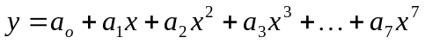

Obviously the data fit exactly the model 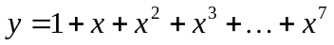 by construction. We should therefore get with our method the solution 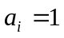 for i=0,…,7.

Let us try our method. We first formulate the problem as a set of inconsistent linear equations:

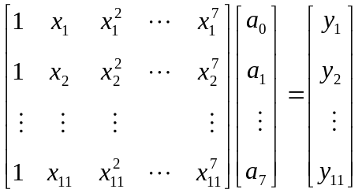

The matrix  that we get is called a Van der Monde matrix. Let us now use MatLab to solve this problem.

We first define the data set:

>> x = (2+(0:10)/5)';
>> y = 1+x+x.^2+x.^3+x.^4+x.^5+x.^6+x.^7;

We then define the matrices and :

>> A = [x.^0 x.^1 x.^2 x.^3 x.^4 x.^5 x.^6 x.^7];
>> b = y;

And we finally solve the normal equations:

>> (A'*A)\(A'*b)
ans =
-1.4562
7.0645
-5.3525
4.6599
-0.2528
1.2548
0.9715
1.0014

Depending on the computer you are using you may get completely different results !

We see that the answer computed is completely wrong containing no significant digits. Indeed, if we compute the conditioning number of the matrix we get:

>> cond(A'*A,inf)
>> ans =
4.8110e+019

We see that even using double precision numbers we can not expect any significant digit.

